**PROGRAM [9]:**

import numpy as np

import matplotlib.pyplot as plt

# Generate x values for the real function

x_func = np.linspace(-4, 4, 100)

# Corresponding y values for the real function (a simple linear relationship)

y_func = x_func

# Generate training data with added noise

x_train = np.concatenate([np.random.uniform(-3, -2, 50), np.random.uniform(2, 3, 50)])

y_train = np.concatenate([x_train[:50] + np.random.randn(50) * 0.5,

x_train[50:] + np.random.randn(50) * 0.1])

# Generate x values for the test data

x_test = np.linspace(-10, 10, 100)

# Plotting

fig, ax = plt.subplots(1, 1, figsize=(10, 5))

# Scatter plot for training data

ax.scatter(x_train, y_train, label='Training Data')

# Plot the real function as a dashed line

ax.plot(x_func, y_func, ls='--', label='Real Function', color='green')

# Set labels and legend

ax.set_xlabel('x')

ax.set_ylabel('y')

ax.legend()

# Set the title of the plot

ax.set_title('Data with Uncertainty')

# Display the plot

plt.show()

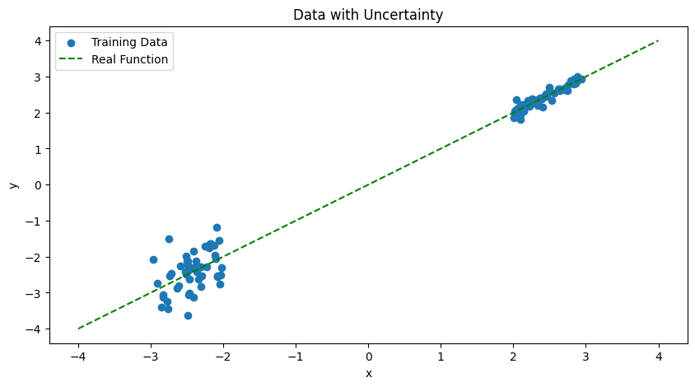**OUTPUT [9]:**